**H2R Data Aggregation Scripts**

The following scripts comprise the H2R data analysis process.

*FIRST—AGGREGATE TO THE SETTLEMENT LEVEL (KI CONSENSUS)*

**Settlements_Merged.R** (KI Consensus)

1. Define the parent folder and set it as the working directory.
2. Define the GIS data file that includes the name/pcode of the geographies.
3. Define the folder where the KoBo output is located (within the parent folder).

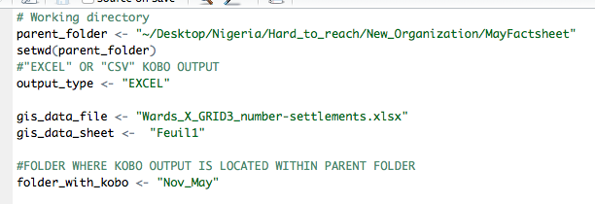

**1.**

**3.**

**2.**

1. Define the name of the cleaned KoBo output (Excel or .csv)
2. Define the year of cleaned KoBo output dataset; if multiple months, then write “ALL”
3. Define the month of the dataset; If multiple months, then write “ALL”

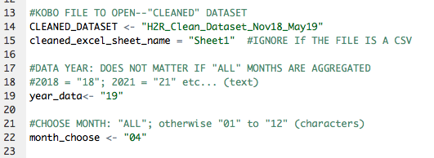

**4.**

**5.**

**6.**

**Select-all and run.**

*LGA & WARD & GLOBAL-LEVEL SETTLEMENT %s*

**Ward_LGA_Results.R**

1. Define the parent folder and set it as the working directory.
2. Define the name of the (.csv) “Settlements_Merged” file
3. Define the Ward/LGA/Global folders (all found in the parent folder).
4. Define the folder containing the GIS data (and sheet).
5. Define the threshold of settlements per-Ward/LGA (e.g., 5%).
6. Choose the 2-digit month of the “settlements_merged” dataset (if monthly). Otherwise enter “ALL” if aggregating the combined monthly [window] settlement-level data.

**1.**

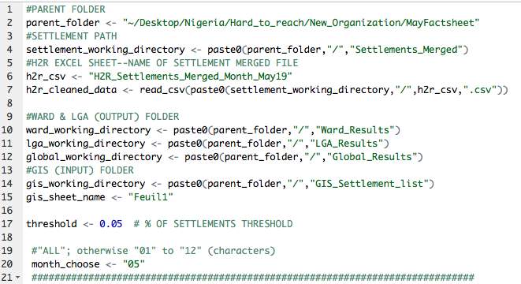

**4.**

**6.**

**5.**

**3.**

**2.**

**Select-all and run.**

*EXTRA: DATA MERGE GLOBAL FILE*

**Global_Results.R**

1. Define the parent folder and set it as the working directory.
2. DO NOT TOUCH: The “FOLDER_AGGREGATED” is the input folder, from “Settlements_Merged” and the “FOLDER_FOLDER_DATA_OUTPUTS” to the correct path to the “Global_Results”
3. Define the “settlements_merged” file name (it is assumed to be a .csv).
4. The “FOLDER_FOLDER_DATA_OUTPUTS” to the correct path to the “Global_Results”
5. Define the name of the (.csv) “Settlements_Merged” file
6. Define whether the “settlements_merged” dataset is monthly (“month”) or aggregated (“window”).

**1.**

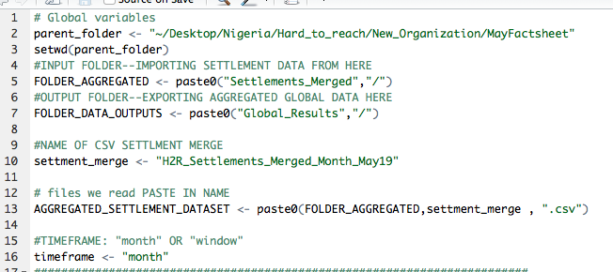

**3.**

**4.**

**2.**

**5.**

**Select-all and run.**